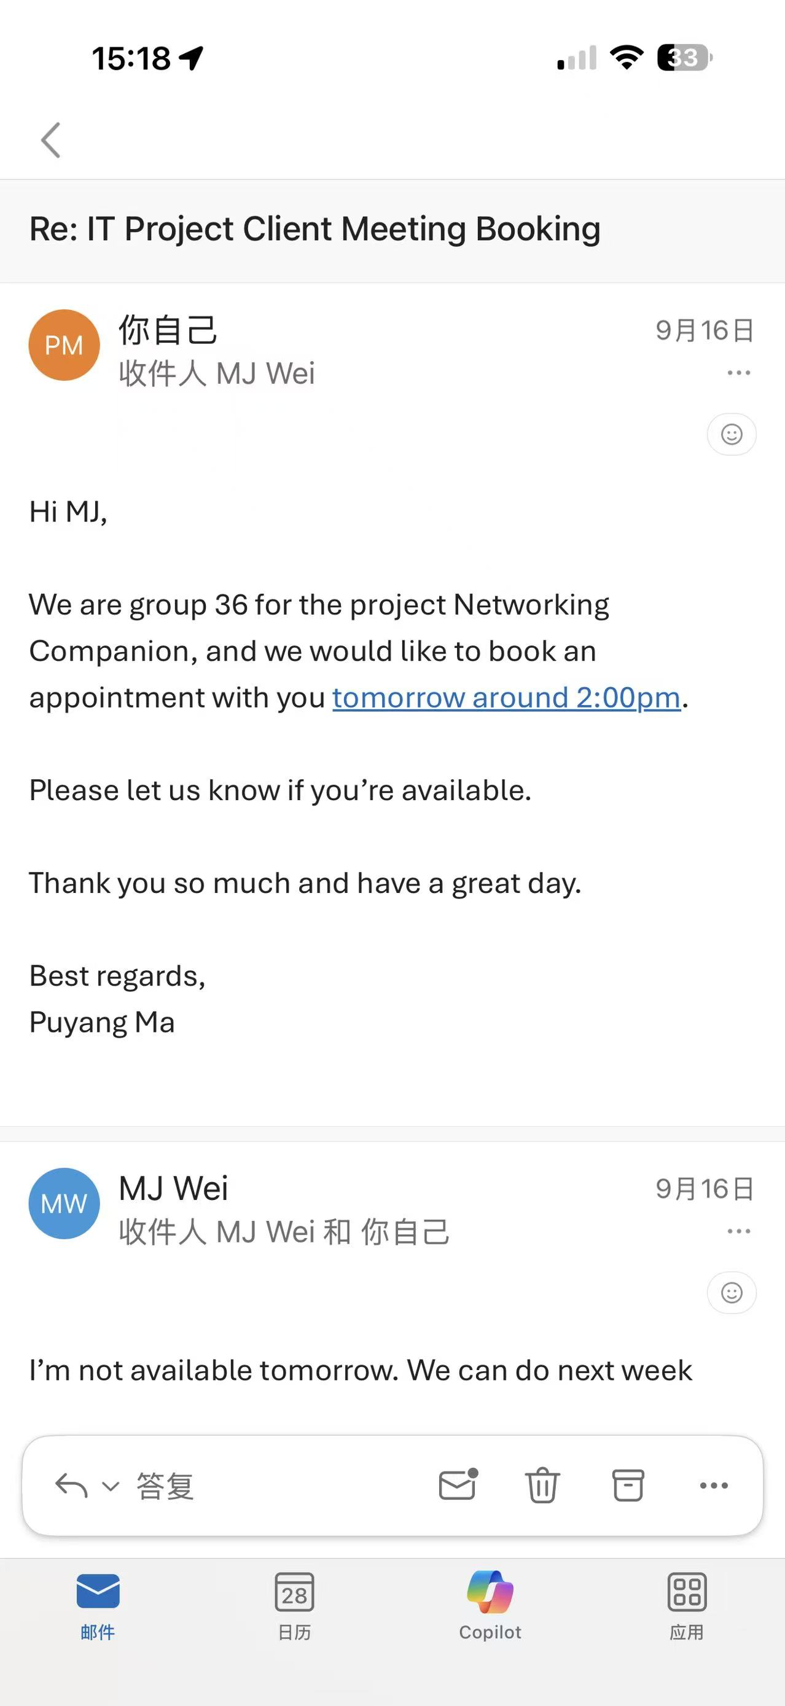
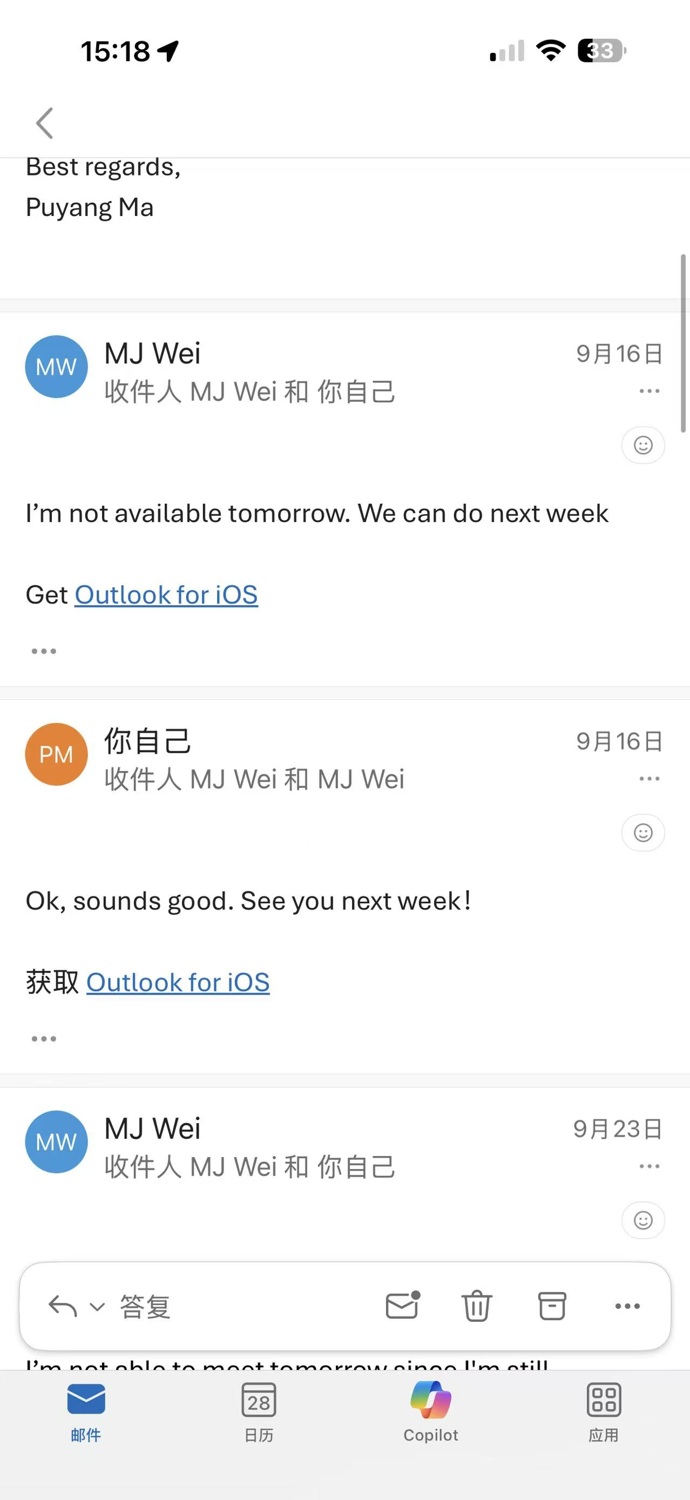ssssssss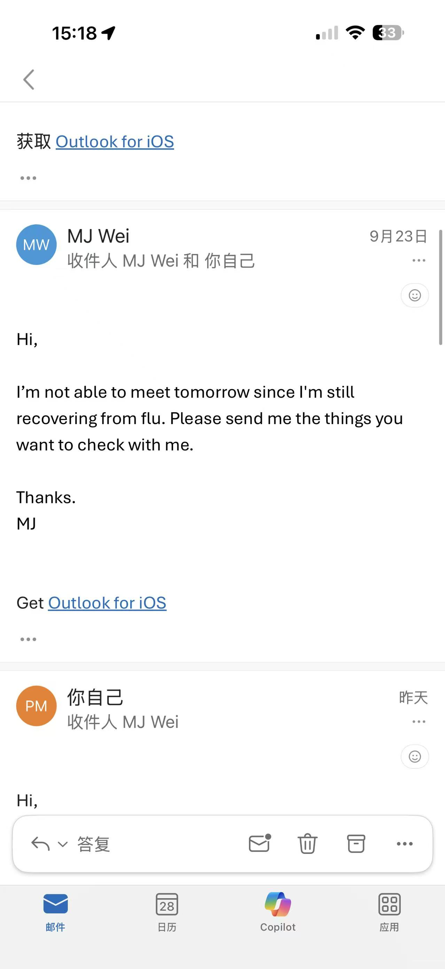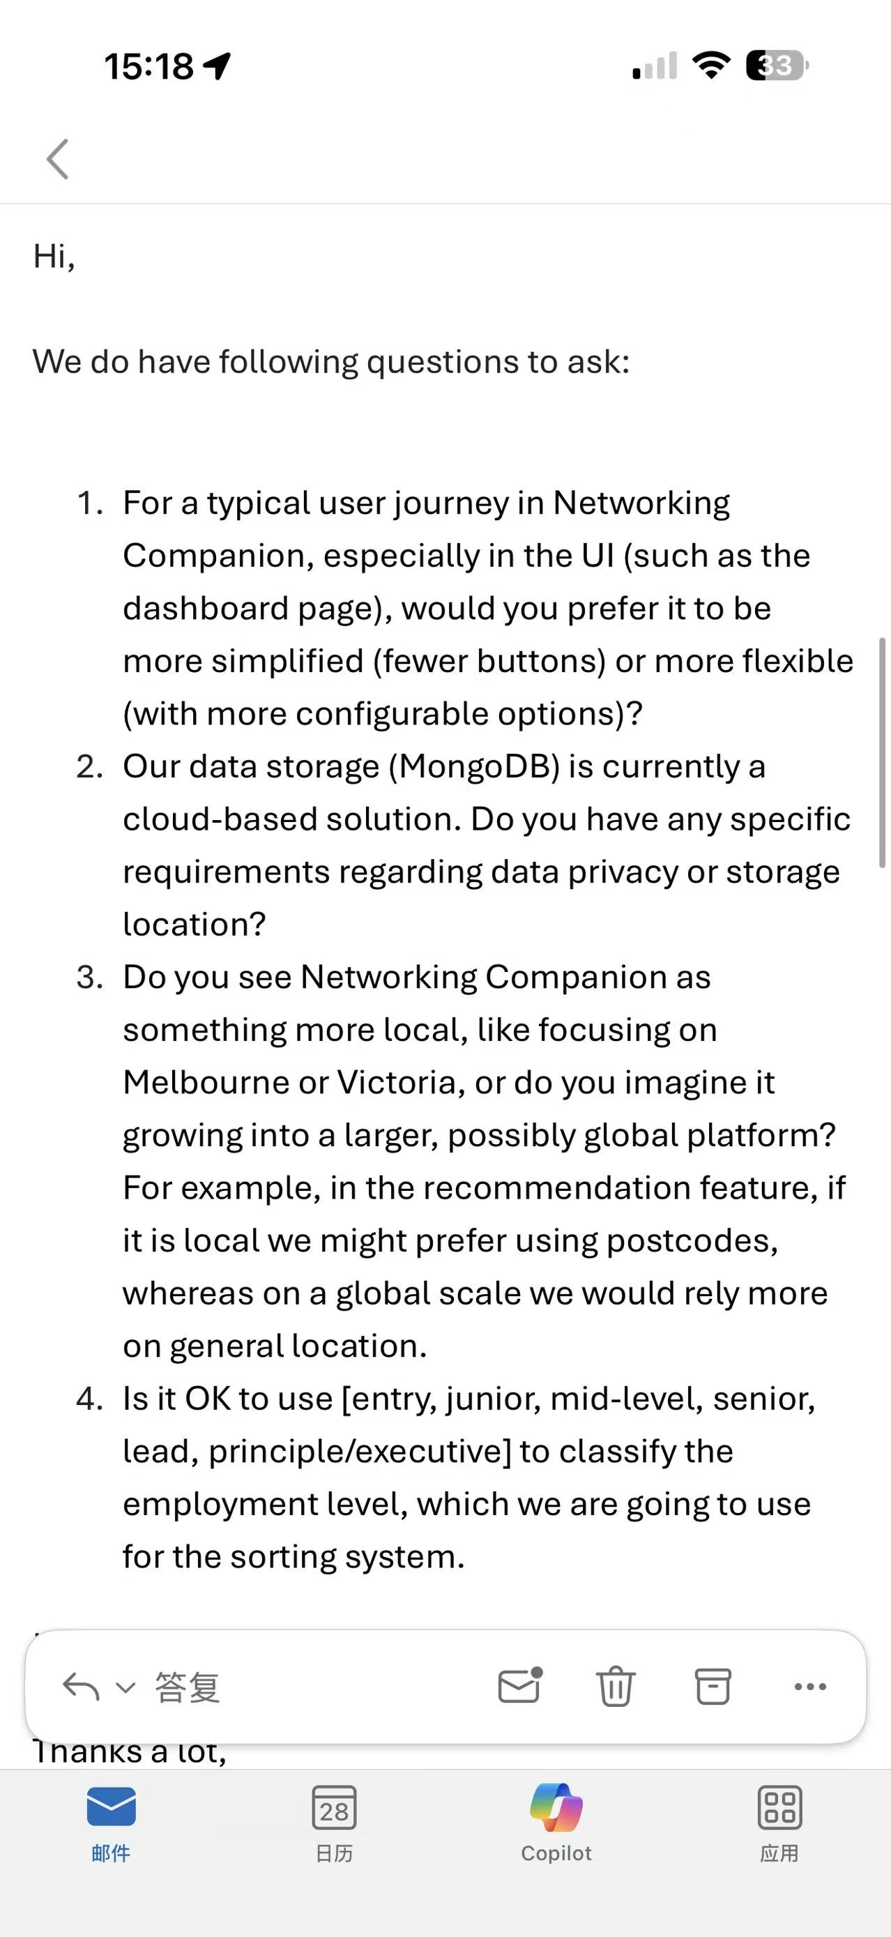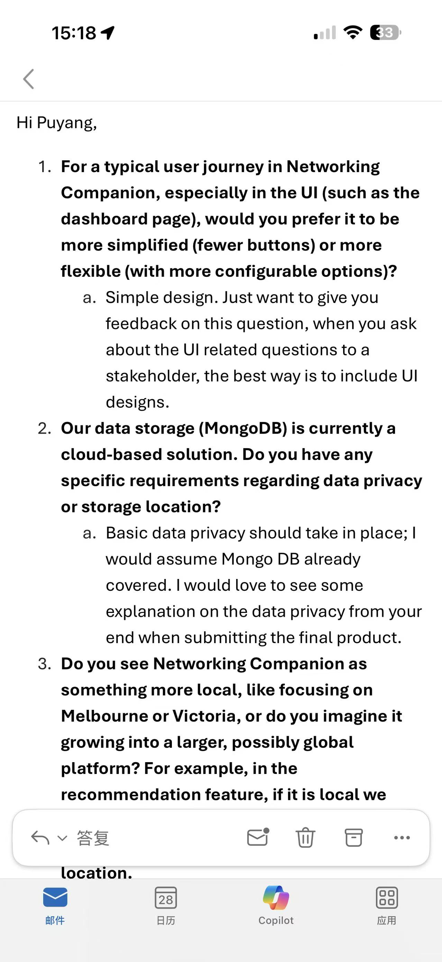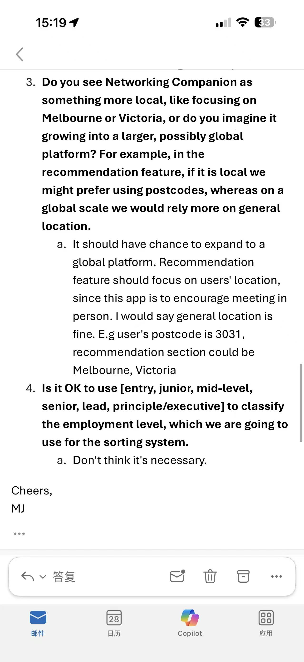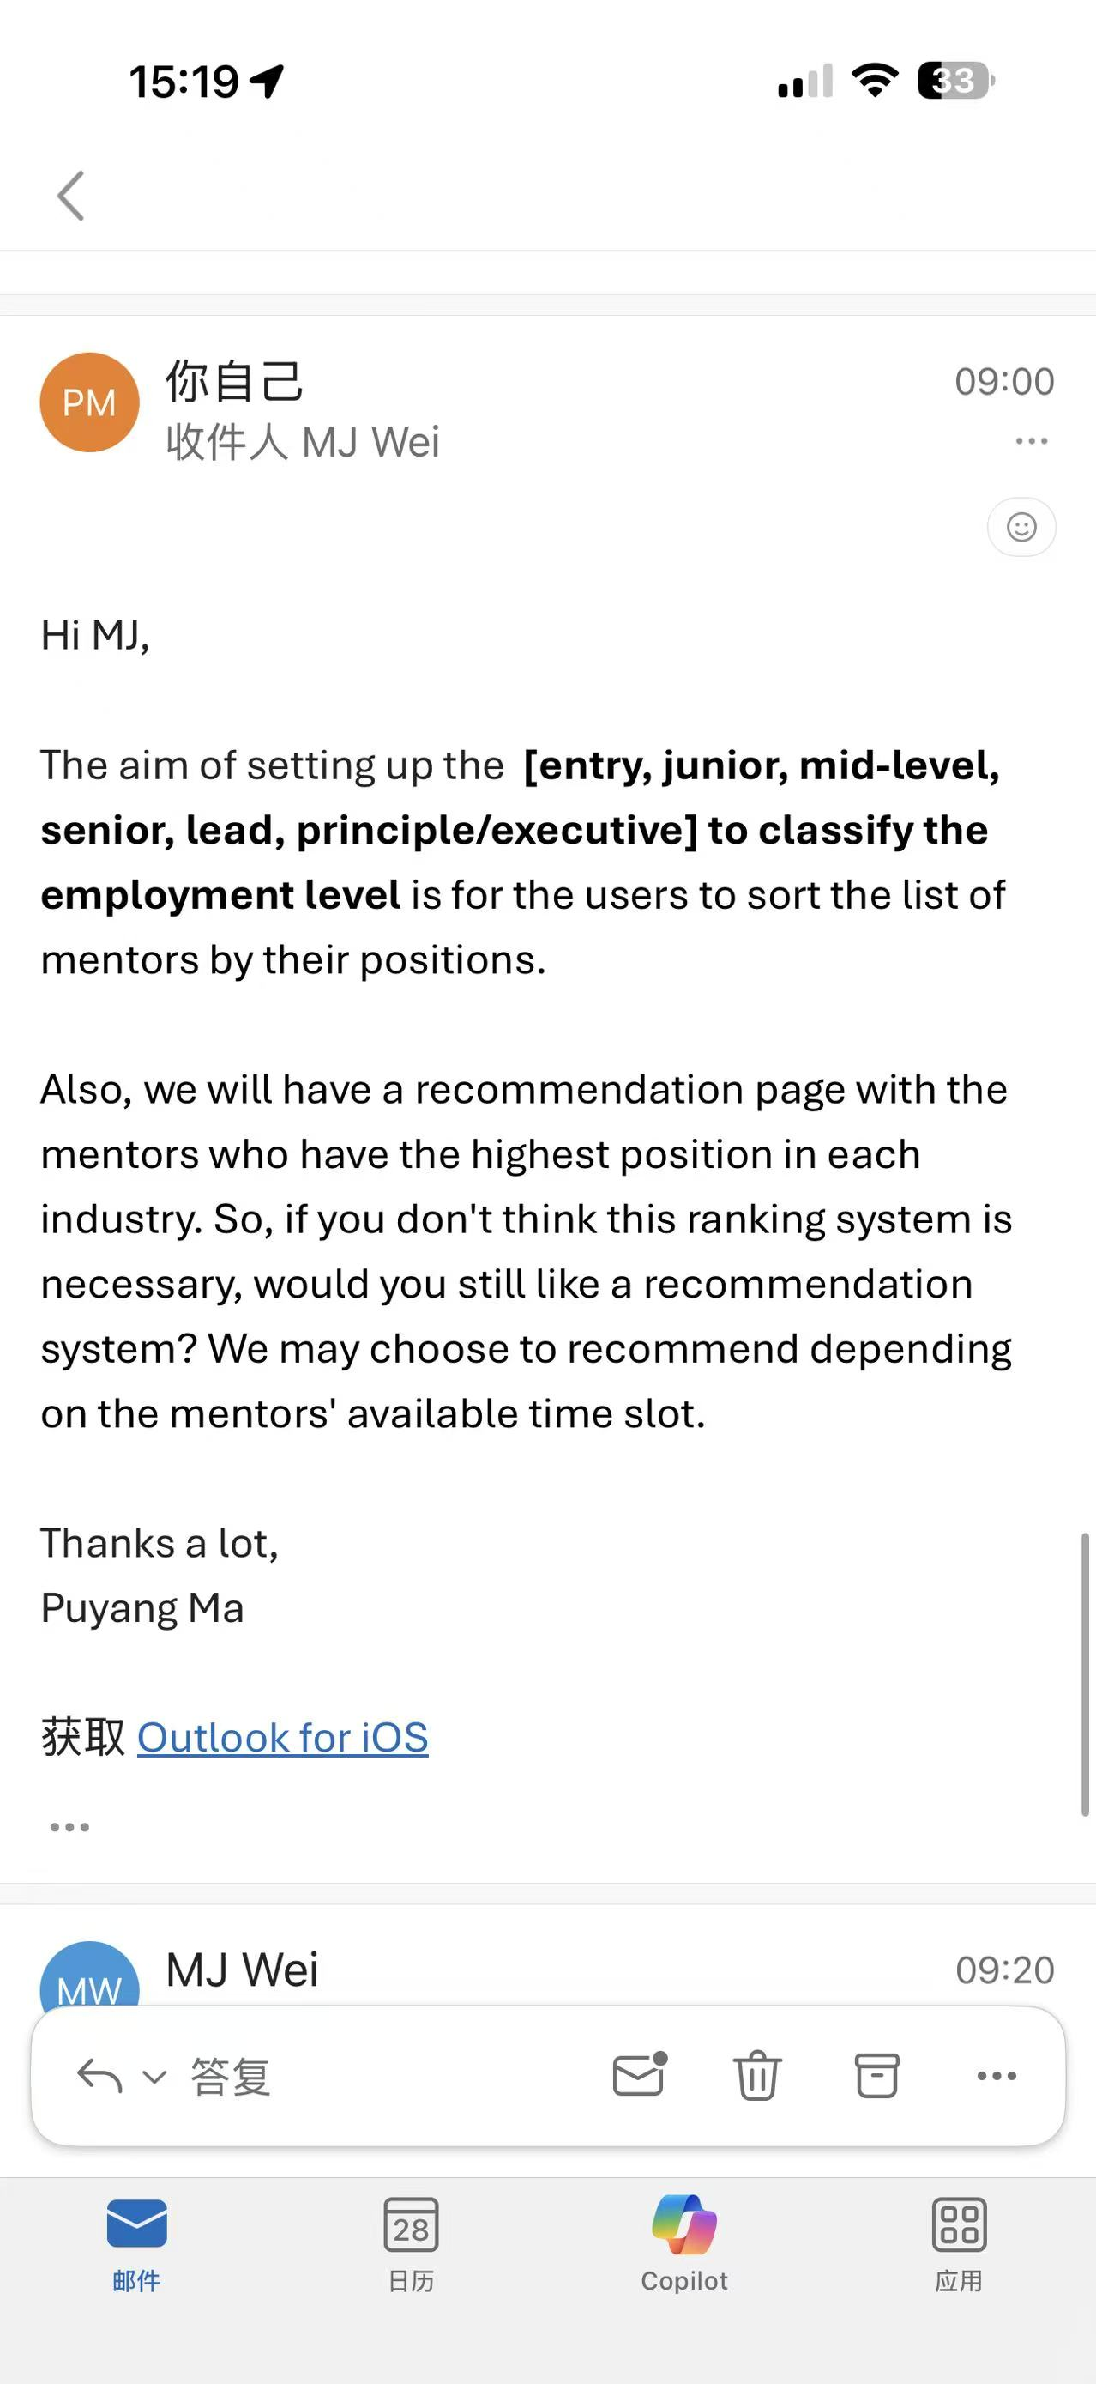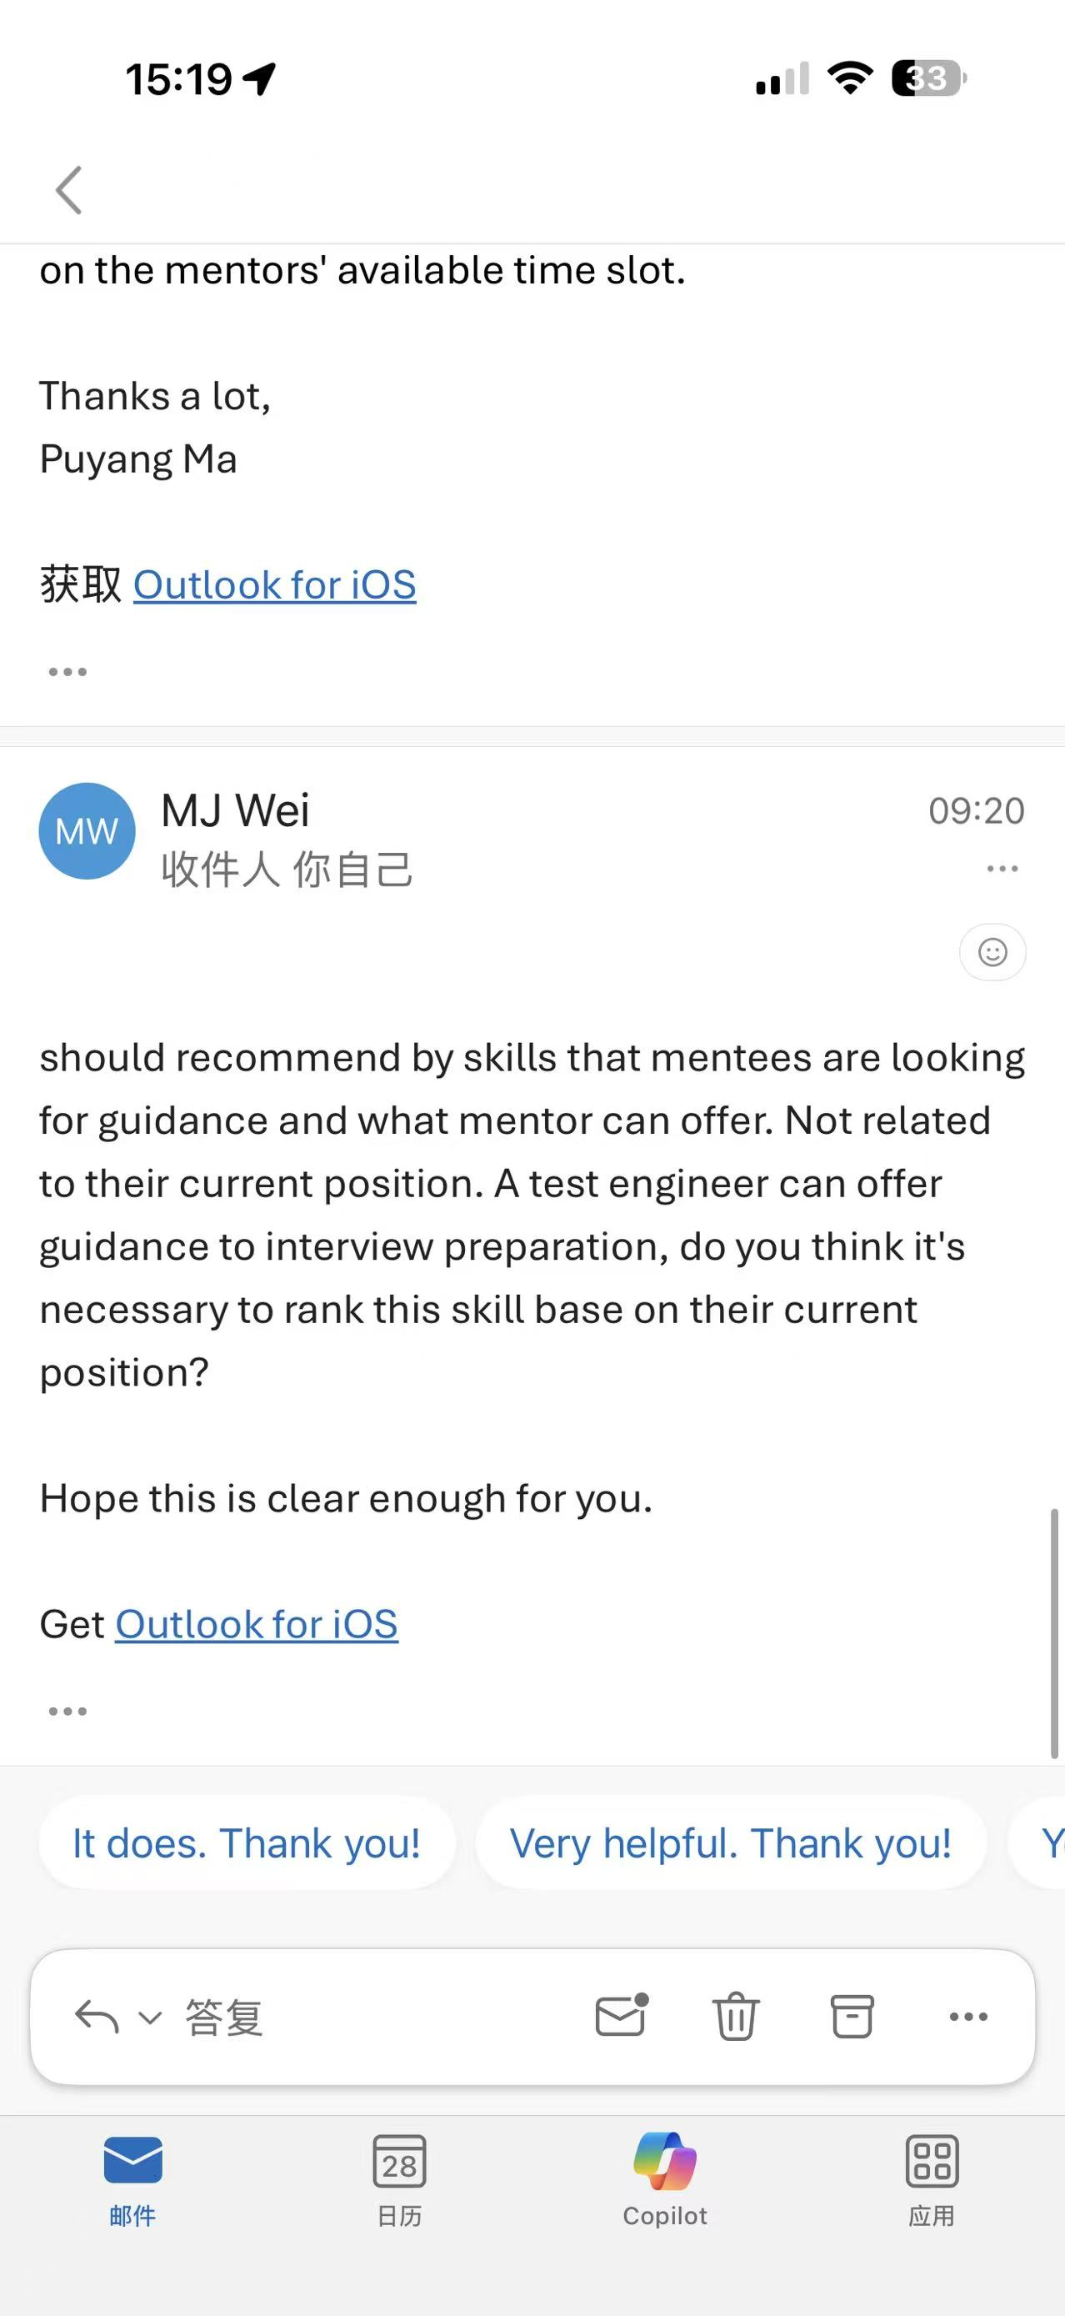
Sept 16th:
First time reach out to the client to make an appoiontment, client is unavailable.

Sept 22nd:
Second time trying to book an appoiontment with the client.

Sept 23rd:
Client was still recovring from the flu and since unavailable. But she offered to answer our questions by email.

Sept 24th:
By a meeting, the team gathered up a few questions regarding the porject.

Sept 27th:
Questions are fianlised and sent through the email.

Sept 28th:
Received feedback from the client.

Actions should be taken:
Include UI designs in future communication with the client.
For the final pruduct, there should be an explanation on data privacy
Finalise the sorting by postcode system, when you search a postcode within Victoria, the recommendation system should come up with Melbourne, which means we should put all the postcode in one state as one unique group, and when recommending mentors, pick from the memtors within that postcode group.
The ranking of position should not be used for the recommendation system. Rather, a new profile information, industry skill set, should be introduced.

